Autumn Days PIANO ONLY Singalong (youtube.com)
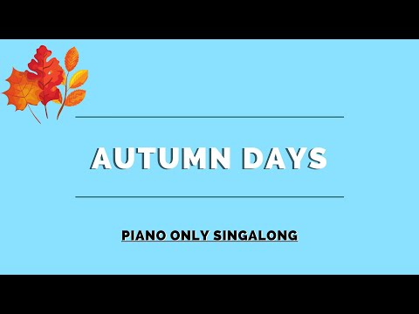

Autumn days
Autumn days, when the grass is jewelled
And the silk inside a chestnut shell
Jet planes meeting in the air to be refuelled
All these things I love so well
So I mustn’t forget
No, I mustn’t forget
To say a great big thank you
I mustn’t forget.
Clouds that look like familiar faces
And a winter’s moon with frosted rings
Smell of bacon as I fasten up my laces
And the song the milkman sings.
Chorus

Whipped-up spray that is rainbow-scattered
And a swallow curving in the sky
Shoes so comfy though they’re worn out and they’re battered
And the taste of apple pie.

Chorus

Scent of gardens when the rain’s been falling
And a minnow darting down a stream
Picked-up engine that’s been stuttering and stalling
And a win for my home team.

Chorus

