5 house points:
Write and perform a song or poem about the water cycle, including the processes of evaporation, condensation, precipitation, and collection. Record a video of your performance.

Create a comic strip that tells the story of a river's journey from source to mouth. Use colourful illustrations and captions to describe the different stages and features of the river.

Use Google Earth to take a virtual tour of the River Severn. Create a short-written summary of what you discovered about the river's path and key features.
10 House points:
Produce a mini-documentary about the River Severn or another major river. Research and script a narration, film footage or use images, and edit the video.
Build a 3D model of a river using materials like clay, cardboard, or papier-mâché. Show the journey from the source to the mouth, including features like rapids, waterfalls, and estuaries.
Research one of the world’s longest rivers (e.g., the Nile, the Amazon, or the Yangtze) and create an engaging and informative PowerPoint presentation about it.

This half term’s House Project is:
Geography
How does a river change from source to mouth?
Due: 10th July 2026

-+

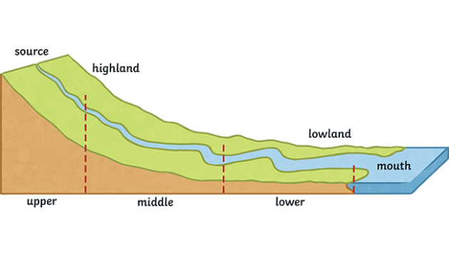
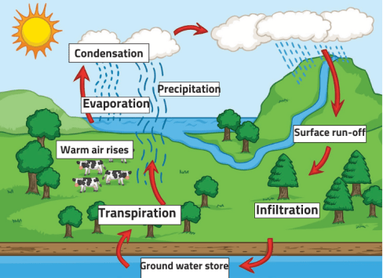

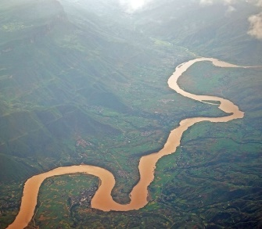
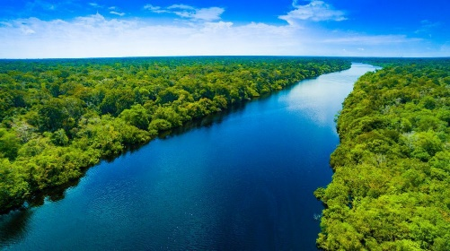
5 house points (SCIENCE)
This half term, we are studying electricity:
Research a famous electrical invention (e.g., the light bulb, the electric motor, the battery). Include diagrams, photos, and interesting facts.
Design a poster that explains how to work safely with electricity. Include safety tips and illustrations to make your poster clear and engaging.
Draw and label the symbols for basic electrical components such as cells, batteries, wires, bulbs, switches, and buzzers. Create a key that explains what each symbol represents.

3 house points:
Write a poem from the perspective of a river, detailing its journey from source to mouth.
Research one of the world’s longest rivers (e.g., the Nile, the Amazon, or the Yangtze) and create a detailed and informative fact file.
Create a word search puzzle using vocabulary related to rivers and the water cycle (e.g., source, mouth, meander, evaporation). Swap with a classmate to solve each other’s puzzles.

Choose projects to achieve your House Points
By all means earn as many as you would like!
Tick off what you have completed to achieve your points.

