-+
10 house points:
- Visit Fort Royal Hill, Worcester Cathedral or the Commandery. Take notes and photographs during your visit and use them to write about what you learnt about the English Civil War.

- Create a recruitment poster to enlist soldiers for either the Royalist or Parliamentarian army during the English Civil War

- Create a PowerPoint Presentation about The Battle of Worcester and its role in the English Civil War. Include causes of the battle, the strategies used by both sides and the outcome

- Investigate and bake a recipe that was eaten during this period

5 house points:
- Diary Entry – imagine you are a Parliamentarian or Royalist soldier fighting in the Battle of Worcester. Describe your experiences and use historical facts to make it realistic.

- Timeline – Create a timeline of the English Civil War, highlighting key events that happened in Worcester. Include dates, descriptions and illustrations!

- Design a coat of arms for both the Royalist and the Parliamentarian army to use. Include symbols that represent their values and beliefs.

- Investigate what else was happening in Worcester during this time.

This half term’s House Project is:
Local History
Which invasion tactics were used during the English Civil War?
Due: Friday 22nd May

Choose projects to achieve your House Points
By all means earn as many as you would like!
Tick off what you have completed to achieve your points.

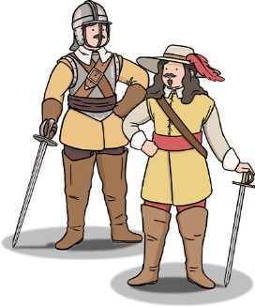
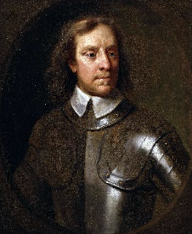


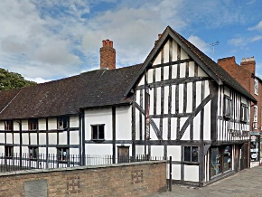
5 house points TIMES TABLES
- Create a times table game to play with your friends.

- Make flashcards for your times tables and ask an adult to test you.

- Write some times table based challenge questions.

3 house points:
- Draw and label a typical Parliamentarian soldier and a Royalist Soldier. Pay attention to details such as their clothing, armour and weaponry.

- Design a flag to be used by the Parliamentarian or Royalist army in the English Civil War.

